Maven Project

Tools Used :

1. JDK 1.7
2. Maven 3.2.2
3. Windows 8

**Note**  
Maven 3.2 requires JDK 1.6 or above, while Maven 3.0/3.1 requires JDK 1.5 or above

* Installation:
  1. **JDK and JAVA_HOME**

Make sure JDK is installed, and “**JAVA_HOME**” variable is added as Windows environment variable.

JAVA_HOME : C:\Program Files\Java\jdk1.8.0_121

## 2. Download Apache Maven

Visit <https://maven.apache.org/download.cgi> download the Maven zip file, for example : apache-maven-3.2.2-bin.zip. Unzip it to the folder you want to install Maven.

Assume you unzip to this folder – C:\Program Files\Apache\maven

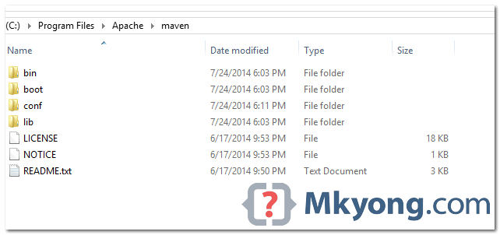

**Note**  
That’s all, just folders and files, installation is NOT required.

**3. Add M2_HOME and MAVEN_HOME**

Add both M2_HOME and MAVEN_HOME variables in the Windows environment, and point it to your Maven folder.

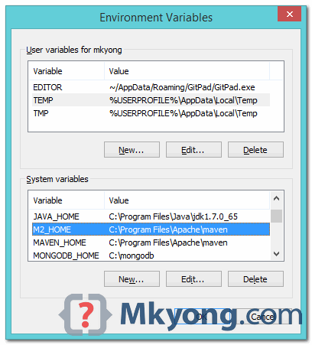

**M2_HOME or MAVEN_HOME**  
Maven document said add M2_HOME only, but some programs still reference Maven folder with MAVEN_HOME, so, it’s safer to add both.

**4. Add To PATH**

Update PATH variable, append Maven bin folder – **%M2_HOME%\bin OR C:\Program Files\Apache\maven\bin**, so that you can run the Maven’s command everywhere.

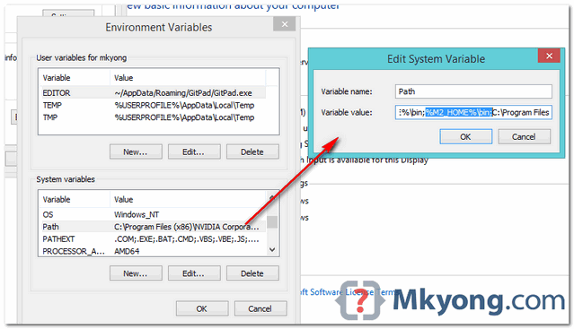

**5. Verification**

Done, to verify it, run **mvn –version** in the command prompt.

**C:\Users\mkyong>mvn -version**

**Apache Maven 3.2.2 (45f7c06d68e745d05611f7fd14efb6594181933e; 2014-06-17T21:51:42+08:00)**

**Maven home: C:\Program Files\Apache\maven**

**Java version: 1.7.0_65, vendor: Oracle Corporation**

**Java home: C:\Program Files\Java\jdk1.7.0_65\jre**

**Default locale: en_US, platform encoding: Cp1252**

**OS name: "windows 8.1", version: "6.3", arch: "amd64", family: "windows"**

**C:\Users\mkyong>**

If you see a similar message, means the Apache Maven is installed successfully on Windows.